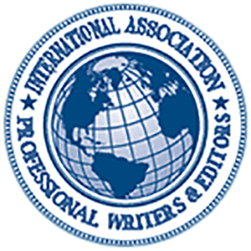
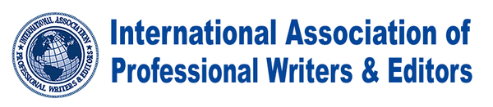
IAPWE | International Association of Professional Writers & Editors
1732 1st Ave
New York, NY 10128

To whom it may concern,
This letter is to serve as confirmation that Joshua R. Simons is a member in good standing with the IAPWE or International Association of Professional Writers & Editors and has provided sufficient evidence through their work to indicate that their abilities are at a sufficient level of proficiency such that they were accepted into our organization and continue to prove to be both a reliable and valuable resource to our organization.

This letter also serves as a recommendation of Joshua R. Simons since we have found this member's skills and aptitude to be such that they would serve as a valuable resource to any other person or company that were to utilize their services.

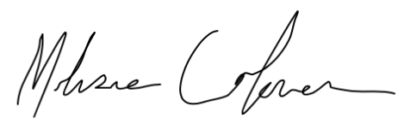
Best regards,

Melissa Coleman
Membership Coordinator
IAPWE | International Association of Professional Writers & Editors

